SE3050 – User Experience Engineering

## ***Lab Sheet 4***

Plan and conduct user research.

# User Research Plan

|  |  |
| --- | --- |
| **Student Reg. No** | **Student Name** |
| IT19148946 | I.T.Manuel |
| IT19220116 | N.I.T.Hewage |
| IT19009964 | Hakeem M.U.M.I |
| IT19395906 | S.A.R.Wijayabandu |

## **Introduction**

This user research is based on peoples’ wave mobile application, which is the online banking mobile application of peoples’ bank. We have chosen some particular user groups to collect their feedback and experience with the application to identify major drawbacks and issues with the system. We used this feed-backs to improve the application in terms of user experience.

Peoples’ wave mobile banking app consists of features like viewing account summary page, one time bill payment, cheque services, pawning services, loan repayment services, money transferring services and so on.

It also has some drawbacks with performances, user interfaces and with some of these functionalities.

This research is done with the intention of overcoming the drawbacks and solving the issues of the application and rebuilding a better version of existing application to provide a good user experience.

**Test Objectives**

1. What do users think about the user interfaces?
2. Are users satisfied with the validations in the system?
3. What users think about the color scheme?
4. What users think about the session time out pattern?
5. Do users receive notifications and alerts?
6. What users think about the loading time of the application?
7. Are users satisfied with the existing navigation of the application?
8. Are users satisfied with the security mechanisms of the application?
9. User’s opinions on the functions that needs to be improved or that needs to be introduced.
10. Are users satisfied with the provided details in the user interfaces?
11. What do users think about the user friendliness on the application?

## **Methodology**

This research was conducted in two ways, mainly using interview and questionnaire. Interview was conducted by selecting two users who use peoples’ wave mobile application very frequently.

The interview was conducted using teams application due to the prevailing situation of the country. We were also able to collect information and feedback of the users regarding the user experience, user friendliness and some major drawbacks of peoples’ wave application from this interview.

We created a questionnaire using Google form and shared it among some users. The questionnaire covered topics related to the user experience and the user friendliness, issues with security, performance and functionalities of the application. From the summary, we got from the conducted questionnaire, we were able to analyze them easily.

Therefore by the analyzed responses, we were able to collect user feedback efficiently and then conduct our user research successfully.

### **Interviewing**

**Script 01**

**Irshad**- Hi Milana Nice to have you with us today. Before we begin, can you give us a brief introduction about yourself?

**Milana**- Hi, Irshad. I am Milana. i am currently working as a Music teacher and an intern and also an undergraduate at sliit.

**Irshad** -ok Milana, so first of all we would like to know how long have you been using the Peoples wave app and what type of services in this app you use mostly?

**Milana**-hmm yeah Irshad, I have been using this app for like 2 years. I mostly use peoples wave application to pay bills and for third party transactions.

**ishika**-So You said that you have been using this app for 02 years, what drawbacks do you find in this application?

**Milana**- Well the major drawback I am facing is not getting a receipt for each third party transactions I do. In order to get a receipt of the transaction I have to log into this online banking website and request a receipt. Which I feel is inconvenient then the next drawback I see is insufficient information in the account summary page.

**Irshad**- So for the drawbacks you mentioned in the application, what are your suggestions you would make to overcome these issues?

**Milana**- yeah, I would prefer if I can get a receipt after each transactions through the app using an email or a notification without requesting via the website. I would also prefer if the account summary contains more details so that I would find it more informative and it be more useful to keep track of the transactions i make.

**Ishika**- ok... What kind of details would you suggest to include in the account summary?

**Milana**- yeah I would suggest if it contains the date and time of the transaction along with mentioning whether it is a credit or debit, Details of bank charges and interest amounts. if there were details as such then it would be more useful for me.

**Ishika**- Milana, I would like to know your thoughts on user interfaces. ?

**Milana**-To be honest I am really not satisfied with the login page. It is less attractive. Its the first page user sees. So I prefer it to be more user friendly and to be more attractive. Also the menu page is also less attractive

**Irshad**-Milana Are you satisfied about the security of this app?

**Milana**-Yes I am. It does not allow the user to take screenshots which is good part of the application and it also resets the password very frequently.

**Ishika**- Would you suggest something more, in addition to the features of security?

Milana-Yes I would suggest if application session would time out after a long while rather than timing out very soon.

ishika- Then what do you think about the loading time of the application?

Milana-hmm what i have noticed the most is loading time of a login.It takes too much time to the process the login which is bit annoying.

Irshad-So finally, what is your overall idea on peoples wave when compared to other banking apps that you have used?

milana- when compared to other applications i have to say that i am not really very happy with peoples wave. As I said it has poor interfaces,

taking too much time to load and no facilities such as receiving a recipt,less details in account summary.

Though there are some issues, Its really worth providing online banking facilities for peoples bank users and I really appreciate the security measures they have taken.

And i would be really happy if they can provide some solutions for the drawbacks in the application.

Irshad-ok milana, thanks a lot for sharing your experiences and ideas on peoples wave with us.

milana- Thank you.

**Script 02**

**Thathsara** - Hi Deshani Nice to have you with us today. Before we begin, can you give us a brief introduction about yourself?

**Deshani** - hi, Thathsara. I am Deshani i am currently working as an business women at Oriflame and I am also an undergraduate at sliit.

**Ravithamara** - so Deshani, first of all we would like to know how long have you been using the Peoples wave app?

**Deshani** - I have been using this app for about 6 months.

**Thathsara** - So would you tell us what are the services you use most frequently in peoples’ wave application?

**Deshani** - As a business women I use the loan repayment option in the app more frequently

**Ravithamara** - Well so while you are using these services, do you find any drawbacks?

**Deshani** - yeah, In peoples wave application there’s an option for loan repayment but there’s no option for loan request. So I have to request a loan by visiting the bank which is very inconvenient.

**Thathsara** - Why do you expect a complex service like requesting a loan via the app ?

**Deshani** - yeah I know that its a complex process but I prefer if the application provides instant loan facilities for less than 100 000/= rupees.

**Ravithamara** - So it can be implemented with a condition that a user needs to have a particular credit limit. What is your opinion regarding this?

**Deshani** – Hmm, well I have no issues with such a condition.

**Thathsara** - What are the other options that you prefer to have in this app, which are not available in the app?

**Deshani** - I have to deal with may other businessmen and employees, so I wish if there is an option to add personal payees and store them so that I can choose them whenever I want to do any transactions.

**Ravithamara** - So in that case, are you expecting to save the account details of the payees you are frequently dealing to make transactions with?

**Deshani**- yes something like that.

**Thathsara**- So I would like to know your user experience with Peoples wave?

**Deshani**- Actually, I would like to say that the login page is not so attractive and it takes too much time for the login process. I am also not that happy with the application resetting the password very frequently.

**Ravithamara** - Do you have any suggestions to improve the app?

**Deshani** - I would like suggest if the user interfaces are more attractive and user friendly, also the application does not show any notifications or alerts when a transaction or transfer is made.

**Thathsara** - Okay Deshani, Thanks for sharing your experiences ideas with us.

**Deshani** - Thank you.

### **Interview Video recording Link:**

<https://web.microsoftstream.com/video/ae8764b6-092c-40bf-8951-2dbcb2b58d57>

### <https://drive.google.com/file/d/1yvEYfETGBVNFAFDpuKMDrZXx2S_1uBsx/view?usp=sharing>

### **Questionnaire**

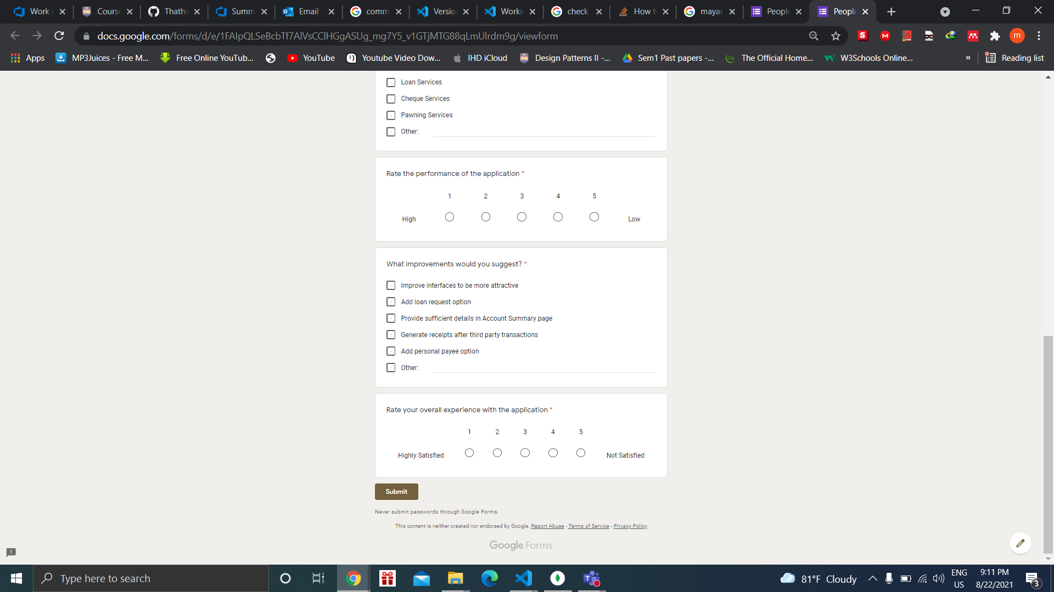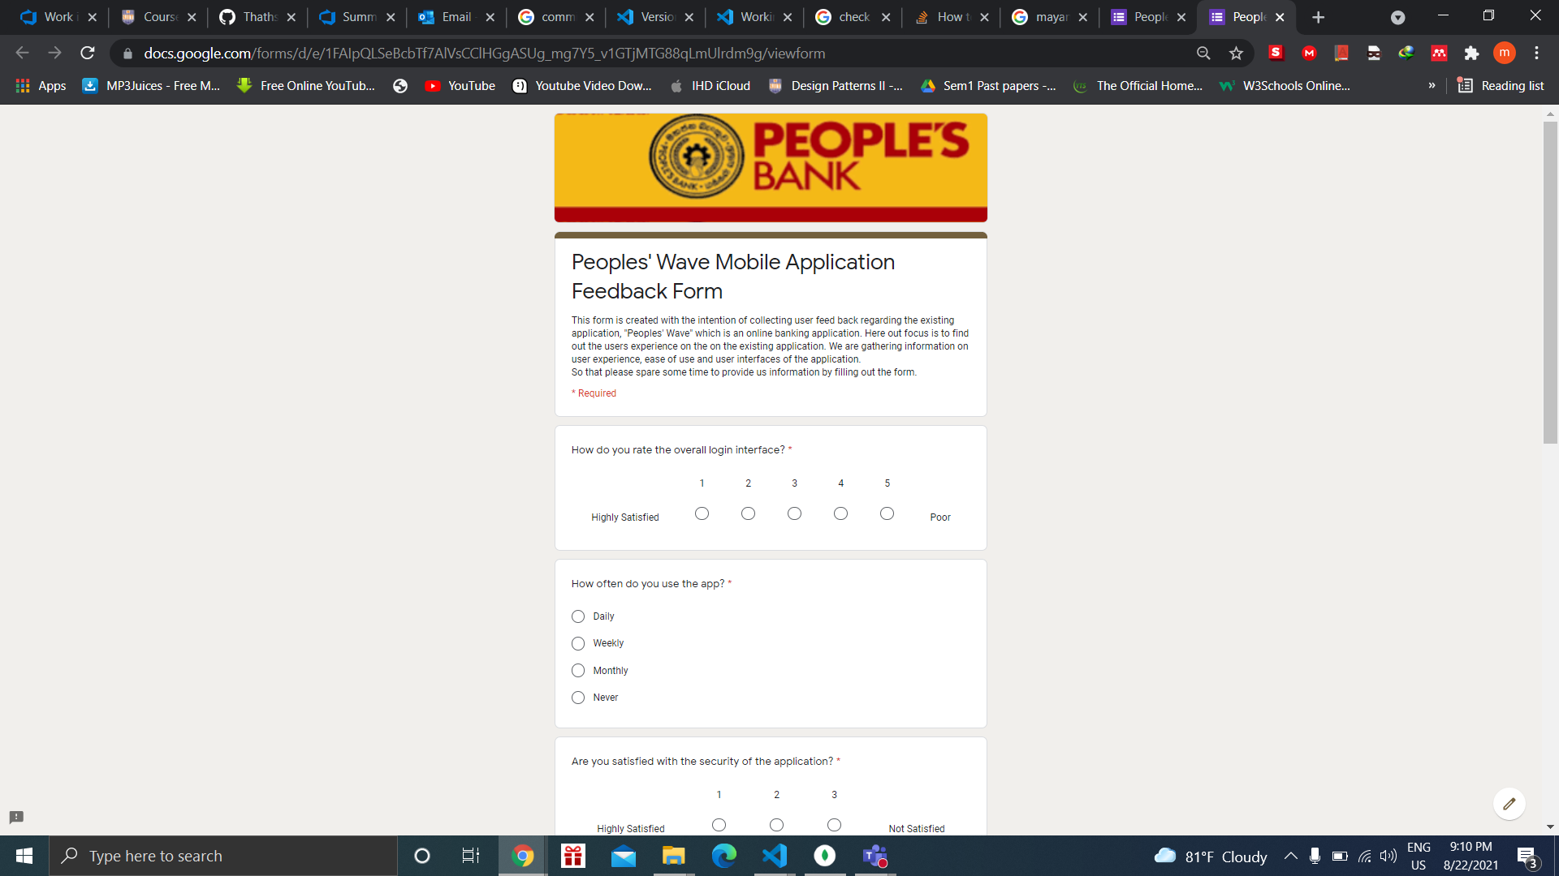

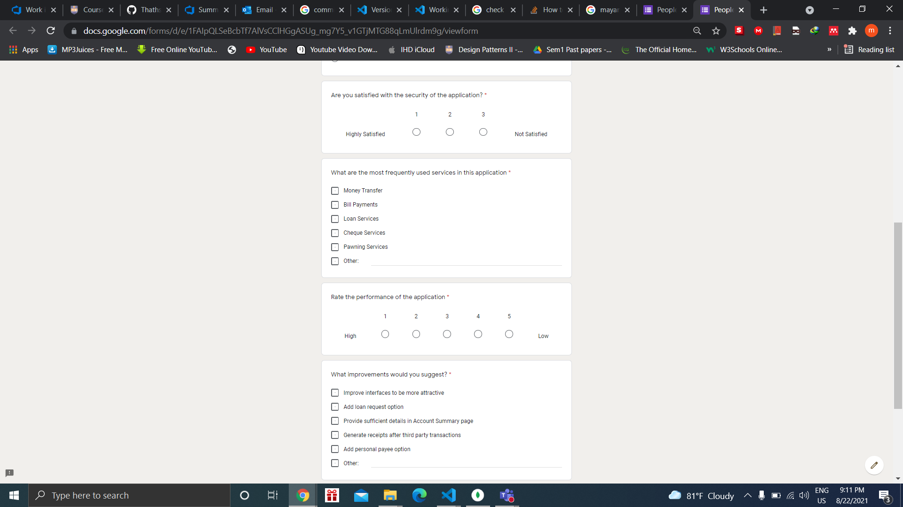

<https://docs.google.com/forms/d/e/1FAIpQLSeBcbTf7AlVsCClHGgASUg_mg7Y5_v1GTjMTG88qLmUlrdm9g/viewform?usp=sf_link>

## **Participant Profiles**

The table below provides a breakdown of the participants selected for testing:

|  |  |  |
| --- | --- | --- |
| **Name** | **Demography** | **Location, Date and Time** |
| 1. Milana Sirithunga | Mr.Milana is a music teacher and he uses this peoples’ wave application very frequently. He shared his experience on application’s drawbacks and it’s user friendliness. He was not happy with the user friendliness and the user interfaces in the application, he mentioned that logging functionality consumes a long time, but he was happy with the security of the system. | **Location**: Virtual Platform (Teams)  **Date:** 8/21/2021  **Time:** 10:30 AM |
| 1. Deshani Dakshima | Miss Deshani is a business women,who works at Oriflame  and she uses peoples’ wave application very frequently.  She pointed out some drawbacks in the system and some of them were loan request service is not available but loan repayment service is available. She suggested that loan request service could be provided online, she also suggested that it would be more convenient if personal payees functionality could be implemented. | **Location**: Virtual Platform (Teams)  **Date:** 8/21/2021  **Time:** 6:00 PM |

### **User Research – Tasks/Scenarios**

|  |  |  |  |
| --- | --- | --- | --- |
| **No.** | **Task Instruction** | **Target** | **Probes** |
| 01. | When a user performs a transaction he will not be able to receive an online receipt via the application. | The application should be generating a receipt after each transaction | Does the user receive receipts for each transactions |
| 02. | A user will be able to perform loan repayments but, he is unable to make loan requests. | A loan requesting service should be available in the mobile application | Can the user make loan requests when he/she needs |
| 03. | A user finds it difficult to insert user account details each time before performing a transaction. | A personal payee management functionality should be available in order to manage user accounts in order to transfer money. | Can user add, update, delete or view personal payees |

## **Plan for Data analysis**

|  |
| --- |
| **Interview**  **Qualitative**   1. Data loading time 2. Alerts and notifications 3. Generation of receipts after 3rd party transactions. 4. Loan request functionality. 5. Personal payee’s functionality. 6. Password resetting duration.   **Quantitative**   1. User interfaces in the system  * Satisfied - 0 * Not Satisfied - 2 * Neutral – 0  1. Security of the system  * Satisfied - 2 * Not Satisfied - 0 * Neutral – 0  1. Performance of the application  * Satisfied - 0 * Not Satisfied - 2 * Neutral - 0   **Detailed Analysis Plan**  When we were analyzing the collected data, we identified that the users are not satisfied with the user interfaces and the performance of the application, but they are satisfied with the security of the system. We are realized that are find the application taking too much time when loading, the system does not display proper alerts and notifications, the system does not generate a receipt after a 3rd party transaction had taken place, the system does not provide the loan request and personal payees services and it resets the password very frequently which the users are not very happy with. |
| **Questionnaire**  **Qualitative**   1. Most frequently used services in the application. 2. Suggested improvements   **Quantitative**  1. Overall login interface   * Highly Satisfied – 5 * Satisfied - 4 * Neutral - 4 * Not Satisfied - 10 * Highly Dissatisfied – 7   2. Application usage   * Daily- 7 * Weekly - 11 * Monthly – 11 * Never – 1   3. Security   * Highly Satisfied – 12 * Neutral - 15 * Not Satisfied – 3   4. Performance   * Highly Satisfied – 1 * Satisfied - 10 * Neutral - 8 * Not Satisfied - 8 * Highly Dissatisfied – 3   5. Overall user experience   * Highly Satisfied – 0 * Satisfied - 7 * Neutral - 14 * Not Satisfied - 5 * Highly Dissatisfied – 4   **Detailed Analysis Plan**  ­­When analyzing the collected data we were able to find out a collected set of responses from different users. In this analysis on **login user interface**, we were able to identify that 5 users are highly satisfied with the login interface, 4 users are satisfied and the same number of users are neutral, 10 users are not satisfied and 7 of the users are highly dissatisfied.  Analysis on **Application usage** represents that 7 users use the application daily, 11 of them use weekly and same number of users use monthly and 1 of them never use it.  Analysis on **Security** represents that 12 of the users are highly satisfied the security of them application, 15 of the users are neutral and 3 of the users are not satisfied.  Analysis on **Performance** represent that 1 of the user is highly satisfied, 10 user are satisfied, 8 of the users are neutral, 8 users are not satisfied and 3 of the users are highly dissatisfied.  Analysis on **Overall user experience** represents that no user are highly satisfied, 7 of the users are satisfied, 14 of the users are neutral, 5 users are not satisfied and 4 of the users are highly dissatisfied.  Further, we also identified that the most frequently used services in this application are Bill payment - 21 users, Money Transfer – 17 users, Check services – 11 users, Pawning services – 10 users, Loan services – 5, View Account Summary – 1 user, Check Account Balance- 1 user  And the improvement suggested by the users are, Generate receipts are third party transactions – 22 users, Provide sufficient details in the Account Summary page – 20 users, Improve Interfaces to be more attractive – 10 users, Add Personal Payee Option – 10 users, Add Loan Request Option – 9 users |

**THE END**